University of Arizona

Ethylene oxide (EtO) Standard Operating Procedure

[This is a template. Fill in all necessary blanks and delete all highlighted areas when complete. Add any sections necessary for your laboratory. This will be appended to your Laboratory Chemical Hygiene Plan.]

Title: Click here to enter the title of your SOP.

Approval Holder (AH): Click here to enter text Approval #: Click here to enter text

Approval Holder Phone Number(s): Click here to enter text

Approval Safety Coordinator (ASC): Click here to enter text

Approval Safety Coordinator Phone Number(s): Click here to enter text

Department: Click here to enter text

- Purpose
This standard operating procedure (SOP) is intended to provide guidance on how to safely store, handle, use, and dispose of ethylene oxide in Enter AH’s name’s laboratory. Laboratory personnel should review this SOP, as well as the appropriate Safety Data Sheet(s) (SDSs), before Describe the procedure or process this SOP will address. If you have questions concerning the requirements within this SOP, contact your Approval Holder (AH) or Approval Safety Coordinator (ASC).

- Scope
[Describe when this SOP applies and to whom this SOP applies.]

- Hazard Description

[Describe the hazards presented by the procedure or process this SOP addresses. What makes it hazardous? Provide an example, if applicable.]

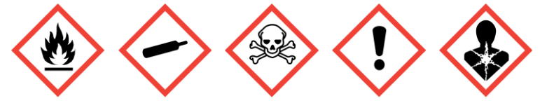
Ethylene oxide (EtO) is an extremely flammable gas at room temperature (flashpoint -20 ºC, flammable range in air 2.6%-100%). Dissolved in water, it remains flammable at a concentration of 4% by volume, making it a serious explosion hazard if poured down the drain. Ethylene oxide can self-polymerize violently upon exposure to heat, acid, or base. Violent reaction can occur with exposure to copper or its alloys, and rust. The heat of burning in a fire may cause the additional hazard of self-polymerization, resulting in explosion.
Ethylene oxide is classified as Category 1B carcinogen, which is assumed to have carcinogenic potential for humans based on animal evidence and animal experiments for which there is sufficient evidence to demonstrate animal carcinogenicity.
Ethylene oxide is acutely toxic if inhaled, causing mucous membrane and respiratory irritation, headache, vomiting, cyanosis, drowsiness, weakness, incoordination, CNS depression, lachrymation, and labored breathing. Delayed effects may include edema of the lungs, paralysis, convulsions and death. The odor (smells like ether, sweet smelling) threshold is > 250 ppm, while its permissible exposure limit (legal limits to which workers may be exposed to the chemical and other hazards without suffering harm) is 1 ppm; therefore, the sense of smell does not provide adequate protection against its toxic effects.
Contact with the skin can cause major damage, including severe blistering; symptoms may take several hours to appear so any dermal exposure should be treated immediately even if effects are not yet visible or felt. The response is amplified if the skin is wet or sweaty. Ethylene oxide is also a skin sensitizer and may trigger an allergic skin reaction. Contact with eyes is severely irritation and may cause irreversible damage. Contact with liquid ethylene oxide can cause severe frostbite.

- Process & Hazard Controls

[Describe the steps needed to set up and complete the procedure or process in safe manner following the hierarchy of controls. Use as much detail as is necessary to ensure all laboratory workers can complete the procedure or experiment safely.]

  - Elimination/Substitution

[Describe any eliminations of hazardous chemicals or processes; alternatively, any substitutions with less hazardous alternatives that could be used to accomplish the task.]

- If ethylene oxide is being used as a sterilant, consider the use of less toxic chemical or physical sterilants; examples include autoclaving, use of chlorine/bleach solutions within a fume hood, UV disinfection, vaporized hydrogen peroxide, and more.

  - Engineering Controls

[Describe any engineering controls (e.g. fume hoods, gas cabinets, local exhausts, blast shields, etc.) that are used to safely accomplish the task.]

Fume hoods or other RLSS approved local exhaust ventilation are required for EtO use. Please see the “Use of Highly Hazardous Gases SOP” available in the University Chemical Hygiene Plan for more information.

- Designing all engineering systems to be explosion-proof in any area where this gas may be present. Container and system must be electrically grounded/bonded.
- Use non-sparking ventilation systems, approved explosion-proof equipment and intrinsically safe electrical systems in areas where this product is used and stored. Copper and its alloys must not be used in any piping or tools used with EtO.

  - Work Practices

[Describe any work practices (e.g. staggering schedules, additional cleaning measures for particulates, etc.) that are used to safely accomplish the task.]

- Pre-plan all work with EtO to minimize time in use and prevent incidents and injuries from occurring.
- Ensure any containers are kept tightly closed at all times.
- Keep in a cool, dry, and well-ventilated area (recommended 2-8o C) and protect from sunlight.
- Avoid alcohols, alkali metals, ammonia, oxidizing agents, chemically active metals, and its salts.
- Use the following signage on any EtO sterilizer or similar machines to indicate hazardous levels of EtO or inadequate protection from EtO.

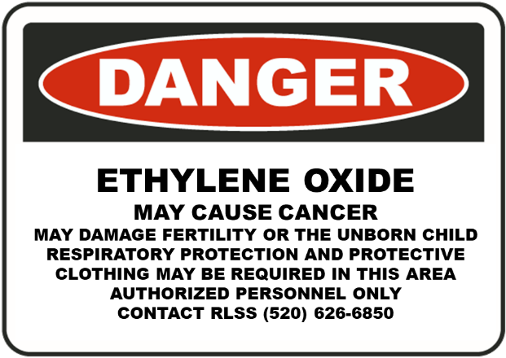

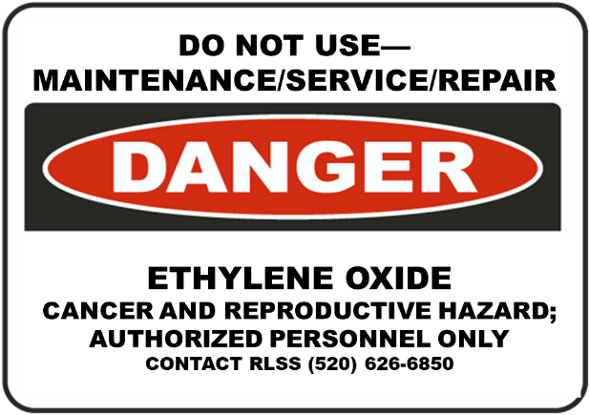

  - Personal Protective Equipment

[Describe the personal protective equipment needed to adequately protect laboratory workers when performing the process or procedure addressed by this SOP. Ensure to specify any personal protective equipment beyond the minimum (i.e. safety glasses, lab coat, gloves, long pants and closed-toed shoes).]

- Hand and Arm Protection: Butyl rubber, Teflon or Silvershield gloves, instead of nitrile, should be used when handling liquid EtO.
- Eye protection: Splashproof safety goggles must be used in areas where liquid EtO or EtO-containing solutions are in use. The use of contact lenses is strongly discouraged in areas where eye contact with EtO may occur.
- Body Protection: 100% cotton at minimum, recommend flame-resistant.
- Respiratory Protection: Respiratory protection may be required if exposures are not able to be adequately controlled by the use of engineering controls or other means. All uses of respiratory protection require RLSS assessment and consultation (for assessment of work, selection of respirator and filtration, and OSHA-mandated medical clearance and fit testing).

  - Transportation and Storage

[Describe how to safely transport and/or store (e.g. ventilated cabinet, flammable cabinet, under inert blanket, etc.) the hazardous chemical(s) or processes.]

Storage
- Protect containers from physical damage; use a hard-sided, leak proof container with absorbent materials for any transport of EtO ampoules or liquid.
- Keep container tightly closed in a dry and well-ventilated place.
- Recommended storage temperature 2-8 ºC. Never store above 52 ºC.
- Store in an area that is: cool, dry, well-ventilated, and separated from incompatible materials (oxidizers).
  - It must be stored out of direct sunlight and away from heat and ignition sources.
  - Recommended storage temperature is 2-8 ºC, but room temperature (~25C) is acceptable. Never store above 52 ºC.
- Electrically bond and ground large containers. Ground clips must contact bare metal.
- Regularly inspect for physical changes or signs of crystallization, damage or leaks. If found, dispose of immediately.
- Do not store near oxidizers or combustible materials, as EtO is highly flammable.

- Spills, Cleanup & Disposal

[Describe how to safely end the procedure or process, clean up the process or spills, and/or dispose of any waste generated.]

Spills should always follow the University Chemical Hygiene Plan Section 8.2.
Spill Cleanup

Spill response should always follow the University Chemical Hygiene Plan Section 8.2.
EtO spills are considered major due to the toxicity and flammability. Immediately evacuate the lab, taking others with you and preventing others from opening the door. Contact 911 if there are injuries and inform RLSS and RMS as soon as possible.
Exposure Response
Inhalation | Ingestion | Skin Contact | Eye Contact
Remove to fresh air and keep at rest in a position comfortable for breathing. If not breathing, give artificial respiration. If breathing is difficult, trained personnel should give oxygen. Call a physician | Not expected to be a primary route of exposure. Give water to drink if victim completely conscious/alert. Do not induce vomiting. Call a physician. . Never give anything by mouth to an unconscious person. | In case of contact, immediately flush eyes or skin with plenty of water for at least 15 minutes while removing contaminated clothing and shoes. Wash with plenty of soap and water. The liquid may cause frostbite. For exposure to liquid, immediately warm frostbite area with warm water not to exceed 105°F (41°C). Water temperature should be tolerable to normal skin. Maintain skin warming for at least 15 minutes or until normal coloring and sensation have returned to the affected area. In case of massive exposure, remove clothing while showering with warm water. Seek medical evaluation and treatment as soon as possible | Immediately flush eyes thoroughly with water for at least 15 minutes. Hold the eyelids open and away from the eyeballs to ensure that all surfaces are flushed thoroughly. Contact an ophthalmologist immediately.

Disposal

Do not discharge gas into in a fume hood to remove it; contact RMS for hazardous waste disposal.

- Enter Additional Section Title

[Add as many sections as necessary to adequately describe how to safely perform the procedure or process addressed by this SOP.]

References:
- https://www.osha.gov/pls/oshaweb/owadisp.show_document?p_id=10071&p_table=STANDARDS
- https://www.balchem.com/wp-content/uploads/2020/01/SDS_ARC_Ethylene-Oxide.pdf
- https://www.ehs.gatech.edu/sites/default/files/ethylene_oxide.pdf
- https://www.cdc.gov/niosh/npg/npgd0275.html

